*Florida International University*

*School of Computing and Information Sciences*

Software Engineering Focus

Feature Document

User Story #**130**

**Team Member:**

Pierre Jimenez

**Product Owner(s)**:

Mohsen Taheri

**Mentor(s)**:

Mohsen Taheri

**Instructor**: Masoud Sadjadi

**User Story** Create Assignment Dashboard

* As a user, I want to be able to update my progress in completing the study steps for an assignment

Acceptance Criteria

* Refer to mockup to make sure the design is correct
* When a user is done with a task they click a checkbox/toogle and the progress is updated.
* When going back to the assignments view the toogles have the same state as when the page was left

**Use Case** #**130– Update Progress**

Details:

Actor: Student

Pre-conditions:

1. Student is logged in
2. Student has created a class
3. Student has at least 1 assignment on dashboard
4. Student has at least 1 task in the Assignment View.

Description:

1. Use case begins when student clicks on a toggle for a task
2. System displays a List of tasks
3. Student presses the toggle to switch from True/ False or False/ True

Post-conditions:

1. When going back to Assignment View the toggles are in the same location as was left before.

Alternative Courses of Action

Exceptions:

Related Use Cases:

**Use Case Diagram**

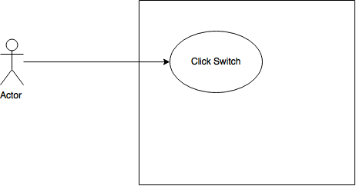

**Sequence Diagram**

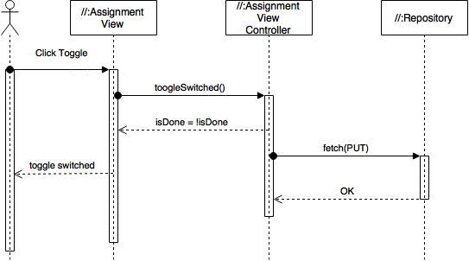

**Class Diagram**

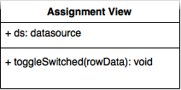

**Unit Test**

**Test Case 1 (Sunny Day)**

**Purpose**

* Ensure that a user can toggle switch

**Precondition**

* User is logged in
* User has added a class
* User is part of a school
* User has an assignment
* User is in the Assignment View

**Input**

* Click on switch

**Expected Result**

* Switch turns from False to True, or from True to False. In iOS this would be pale to green, or green to pale, respectively.

**Actual Result**

* Switch toggles correctly

**Visual User Guide**

